IMMACULATE CONCEPTION P.S.R
Parent Handbook

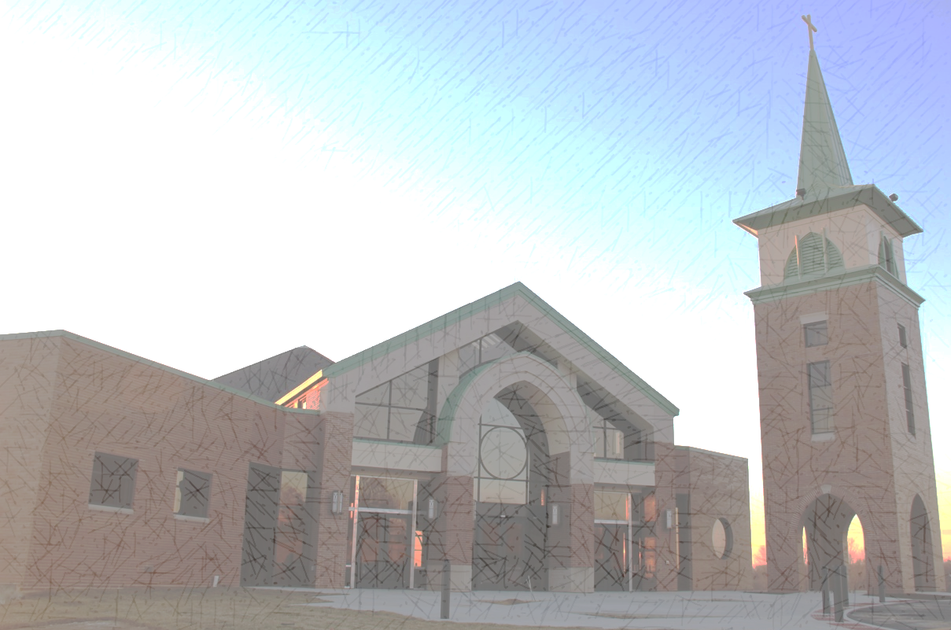
(Revised August 2023)
Rebecca Husman – P.S.R. Coordinator
rhusman@iccmail.org, 618-281-5105 x353
Lizanne Young – Director of Faith Formation
lyoung@iccmail.org, 618-281-5105 x354

REGISTRATION

Registration for the following school year begins in the Spring semester and should be completed no later than June 1. To enroll, please visit the parish website (www.icc-columbia-il.us) and click on the PSR tab. If you are unable to complete your registration & parish stewardship information by June 1, please contact the PSR Coordinator or IC Business Manager. Enrollment after July 1 may be subject to a late fee, and notice will be given.

FEES & FULL STEWARDSHIP

Immaculate Conception has been a Full Stewardship Parish since 2013, meaning that our parish invites all members to make a full response to our baptismal call to discipleship by participating in the celebration of the Eucharist each weekend, and by returning the first portion of our blessing to our loving Creator via to time, talent and treasure.

As a Full Stewardship Parish we do not charge our parishioners for tuition at our parish grade school (ICS, grades K-8), or our Parish School of Religion (grades K- 8). Instead, Immaculate Conception parents of ICS/PSR students are required to complete and return a Stewardship of Time, Talent and Treasure commitment form annually, and to fulfill their commitment to be active parishioners by attending Sunday Mass and practicing regular and generous stewardship of their Time, Talent and Treasure. Our hope is that at some point, a majority of stewardship participation will eliminate the need for any fees, but at this time, it is necessary to cover book fees at ICS/PSR.

Fees for the 2023-24 PSR Year are as follows:
Parishioners in Grades K, 1, 3, 4, 5, 6, 7, 8 $55.00
Parishioners in Grade 2 (additional cost for sacramental prep) $70.00
Non-Parishioner Grades K-8 $200.00
Fees are due at time of registration unless other arrangements are made.
For confidential assistance, please contact IC Business Manager Kara Dell-Hunt
at 618-281-5105 x350 or kdell-hunt@iccmail.org

A late registration fee may be added if registration fee is not completed by July 1st.

Refunds: Refunds for PSR fees will be granted on a case by case basis if a family leaves before the school year is completed.

STUDENT SAFETY

For the safety of the children and volunteers, the same crisis management plan for school emergencies will be followed. IF an emergency should occur please make sure to check emails and texts for any messages.

CLASS INFORMATION

P.S.R. Class is held on Wednesday evenings in the Catholic Education and Activity Center beginning at 6:30 sharp. Please plan to arrive at 6:20.

Parent Involvement
Being a Catholic in the world today calls us to daily conversion in response to our baptismal call. Parents are challenged to take seriously the time and commitment to help children grow their catholic faith.
Enrolling a child in the Parish School of Religion is only one of the ways in which a parent can help their child attain a proper religious education. There are many other things a parent does to help their child to know God's love. Ask yourself these questions:
- Do I let my child know that I love God?
- Do I show my child how to help others?
- Does our family attend Mass each week and on Holy Days of Obligation?
- Do I set a good example at home by praying with my child before meals and at bedtime or other times?
- Do I see that my child attends classes regularly and promptly?
- Do I show an interest in what my child learns by discussing their lessons with them, assisting with homework, and asking them to share their books, papers and projects?
- Do I work with their teachers to help my child know their prayers and religion lessons?

Strive to answer "YES" to all these questions to help your child realize the importance of loving and serving God and trying to get to know God better every day.

Home Teaching
If special circumstances keep your child from attending classes in person, please contact the PSR Coordinator to set up a home teaching plan for the family.

Special Needs Children
We will work with you, your child and their Catechist to meet your child’s special needs for sacramental preparation and continuing religious formation.

Volunteers
Our program is only successful because of help of volunteers. We need catechists, classroom aides, substitute catechists and office volunteers. For those new to the program, the catechists are responsible for teaching the class and the aides help the catechist with lessons, attendance, projects, etc. Substitute catechists fill in for the catechists and may specify the grade they would like to substitute for. The office volunteers collect attendance sheets, lock and unlock doors during class time, etc. All volunteers must complete mandatory diocesan paperwork including a background check and complete an online child protection course. Catechists will be required to attend a parish training session at the beginning of the year. Additional sessions will be held during the year. If you love God and are practicing your faith, you are well qualified to be a catechist!

Mass Attendance
It is an obligation to attend Mass on Sundays and Holy Days and is the most important part of religious formation, regardless of age. Please be sure children participate in the liturgical life of the parish through weekly Mass attendance.
Immaculate Conception Parish Mass Schedule
Saturday 5:00 pm
Sunday 7:00, 9:00, & 11:00 am

You may also attend the Catholic Mass at another parish of your choice to accommodate vacation, sports, visit to relatives, or just for fun! Just make sure you get to Mass on the weekend!

Prayer
Parents, we rely on you to take the responsibility of making prayer an integral part of family living. Your child will also be saying prayers each week in class and may be asked to work on memorizing prayers at home. Please help your child learn our foundational prayers.

Reconciliation
The Sacrament of Reconciliation is one of the most beautiful, visible expressions of love and mercy from our invisible God. Allow your child to accompany you to Reconciliation to pray while you receive the sacrament, and encourage them to be “next in line.” Immaculate Conception offers Reconciliation in church every Saturday from 4-4:30pm. We also share Communal Reconciliation for all prepared PSR students during Advent and Lent, and parents are welcome to join the service.

Books & Supplies
Your fees cover all supplies needed. If there is a special project, a catechist may request items from home for a particular class (paper towel roll, for example).

Students will be issued books which are usually kept at school but if a catechist sends the textbook home to complete assignments, it should be brought to class the following week. If a textbook is lost, you will be charged to replace the textbook.

Students in 4th grade receive bibles for use that year, through 8th grade, and then to keep. Please make sure your upper-grade student brings the bible to class every session. (We have a special blessing at our first PSR Mass every year, please join us!)

ATTENDANCE

Please make every effort to have your children in class each week and on time. Our classes are built on each other and carry a central focus throughout the year and the students work together as a team. Please help us educate your child about making God the number-one priority in your family by talking with your child about choosing PSR attendance over other activities. (Please advocate with scout leaders, coaches, etc., for your child to keep Wednesday evenings free for PSR. We cannot do that for you.)

Sacramental preparation begins at least one year prior to the year the sacrament is received, so Grade 1 is essential for students receiving First Eucharist, and Grade 7 is essential for students anticipating Confirmation in 8th grade. Please talk to the Director of Faith Formation, Lizanne Young, if you have questions about sacramental preparation.

If your child has five consecutive absences, we will notify you to discuss whether your child will remain in the program.

Arrival/Dismissal protocol. Please drop off and pick up your students on time out of respect for our volunteer catechists, and our students (the children have had a long day!). If your child is in grade K thru 3, please drop off and pick up at the classroom door. If you have made arrangements for carpooling, please let the PSR Coordinator know.

If late arrival or early dismissal is necessary, notify please contact the PSR Coordinator. On the day of an early dismissal, please follow these procedures:

- Remind the Office Volunteer and Classroom Catechist at the beginning of the session.
- Allow the Office Volunteer to retrieve your child at your early pick-up time. (Parents should not go to the classroom.)
- In the case of older children (Grades 5-8), they can watch the time themselves, but must check out in the office before leaving.

CURRICULUM
Kindergarten
Allelu! Growing and Celebrating with Jesus – The interactive activity sheets are designed to be a learning tool for the classroom and then sent home to share with the family during family mealtime. The Activity Sheets double as the child's personalized place mat for the dinner table. They provide both structure and support for important family rituals such as eating meals together, praying together, reading Scripture, and talking about their faith.
What better time is there for families to come together and talk about their faith than at mealtimes? In fact, some of the most significant moments of Jesus' own ministry centered around meals with others. The Eucharist -- a holy meal -- is at the center of Catholic worship.
Kindergarten and 1st grade lessons prepare the 2nd grade students for the next step in the Sacramental journey.

1st, 2nd,3rd, 4th, 5th & 6th Grades
Alive in Christ - This curriculum effectively implements the six foundational tasks of catechesis (National Directory for Catechesis, 131). Activities, features, and questions throughout the text prompt children to relate knowledge of our Catholic faith with their life experience. Each lesson provides practical examples of ways we worship, live, pray, and serve together as Catholics and introduces children to Catholic figures who stand as models of heroic virtue in everyday life.

7th & 8th Grades
Decision Point - A Confirmation program specifically developed to engage young Catholics in a meaningful conversation about Catholicism. The content meets junior high students where they are in their everyday lives, and teaches and inspires students to respond to God’s grace.

Studies will be supplemented with the Confirmation Journal received in 7th grade during Lent, and activities with their confirmation groups made up of all parish candidates

LEARNING ENVIRONMENT

Students are expected to follow the rules and regulations. Courtesy, cooperation and respect are expected from students towards each other and the catechist. Care must be taken of classroom property including tables, chairs, walls, projects, etc. Cell phones should be used for emergency purposes only or at the catechist’s request.

- Students should act respectfully toward all adults and fellow students
- No toys or games
- No food or drink should be brought into the classroom. Snacks will be provided at the catechist’s discretion. If class snacks are approved by catechist, they are required to be individually wrapped items with an ingredient label available. WE ARE A NUT FREE ENVIRONMENT.
- Student may not touch any items inside the desks, lockers, displays or any other personal property inside the classroom. (The PSR student will be responsible for replacing or fixing any broken or missing item.)
- Cell phones may only be used for emergency purposes, or at the catechist’s request (for example, to look up a saint or other research related to the class). No texting or social media during class time; the catechist may choose to collect cell phones at the beginning of class.
- Parents are asked to refrain from texting/calling their children between 6:30-7:30pm; in case of emergency during class time (or minor emergency: “I’m running late”), please reach out to the PSR Coordinator and/or your child’s catechist.

Disruptive Behavior
1st Step: Catechist will speak to the child when the incident occurs.
2nd Step: If the behavior continues, the child will be sent to the office to see the PSR Coordinator.
3rd Step: If the PSR Coordinator thinks the circumstances warrant parental involvement, the PSR Coordinator will call the parents and notify them of the situation.
4th Step: If the behavior continues after a call to the parents, the PSR Coordinator will schedule a meeting with the parents and the student to discuss how to resolve the situation. The Director of Faith Formation may be consulted and included.
5th Step: If the matter cannot be resolved, the parish Pastor will be consulted.

Change of Address or Phone Number
Please notify the Parish Office if your phone number, email address or home address, change during the year. This is especially important for those receiving Sacraments as we mail out meeting notices and important information during the year.
FOR YOUR CHILD’S SAFETY, WE MUST BE ABLE TO REACH YOU BY PHONE AT ALL TIMES WHILE YOUR CHILD IS ON IMMACULATE CONCEPTION PARISH PROPERTY.

Student Illness or Injury
If a student becomes sick or injured during class, the Catechist or aide will bring her/him to the office or contact the office and someone will come to get the child and the parents will be notified. We will not under any circumstances dispense medication to the child even if the Catechist knows the child and the parent. The office will not dispense medication for the parents. If a student requires medication during class time; the parent must come to the office to administer the medication.

INCLEMENT WEATHER

We follow the inclement weather cancellation decision provided by Columbia Unit School District 4. If school is cancelled or has early release due to weather, we too will cancel classes.

If the weather situation develops after the regular school day, you will be notified by email and text.

